**SEQUENCE**

**MODULE: 1**

**Definition:** A sequence is a function whose domain is N and whose codomain is R. Given a function *f* : N $→$ R, where $x_{n}$ = *f*(n) is the nth term in the sequence.

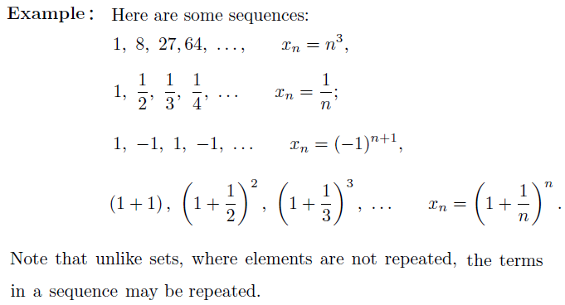

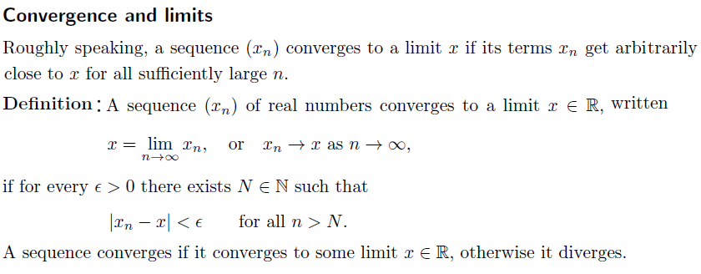

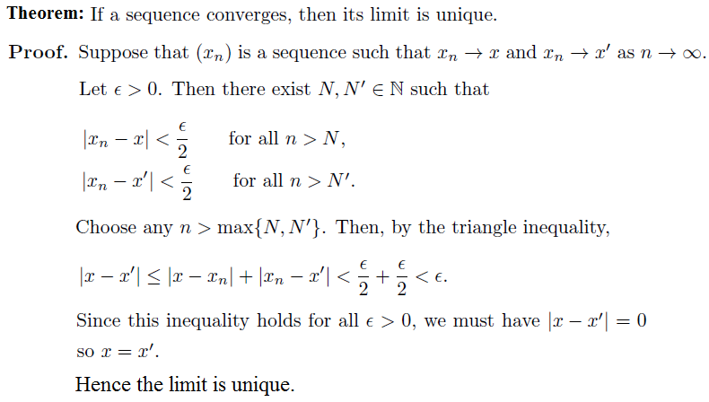

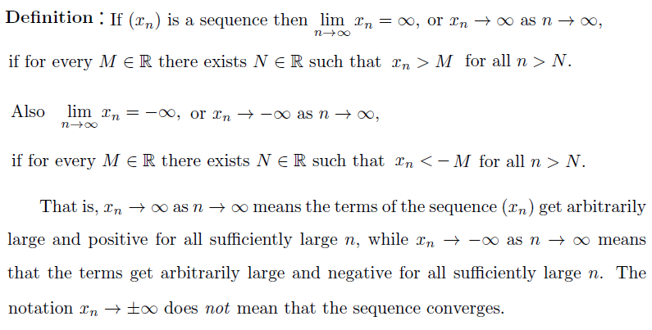

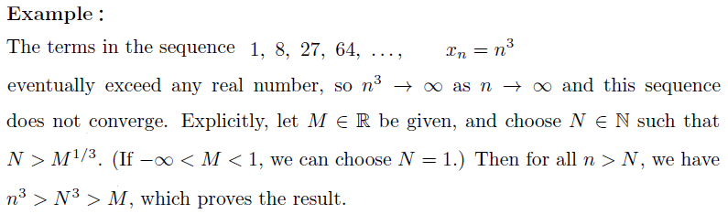

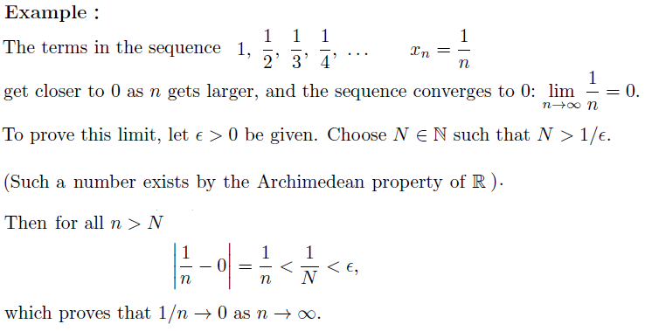

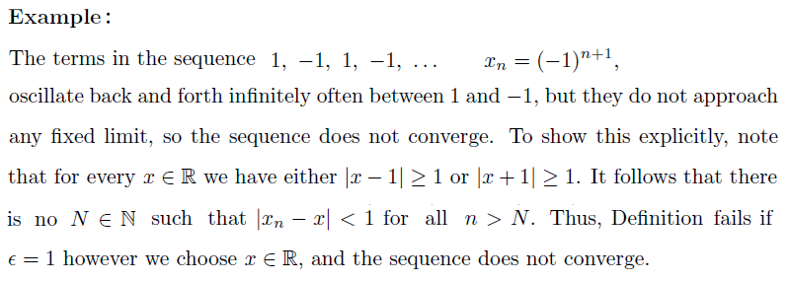

**Theorem:** Let $\lim_{x →∞}{f\left(x\right)=L}$, and suppose that $s_{n}$ = *f(n)* for large n. Then

$\lim_{n →∞}{s_{n}=L}$.

