Date: 15.04.2020
GRAPH THEORY
MODULE – 1
A graph is a collection of vertices connected to each other through a set of edges.
The study of graphs is known as graph Theory.

Definition: A graph is defined as an ordered pair of a set of vertices and a set of edges. G = (V, E), here V is the set of vertices and E is the set of edges connecting the vertices.
Example:
E
C
B
D
A

In this graph, V = {A, B, C, D, E} AND e = {AB, BC, CD, DA, DE}

Types of graphs:
1. Null Graph
2. Trivial Graph
3. Non-directed Graph
4. Directed Graph
5. Connected Graph
6. Disconnected Graph
7. Regular Graph
8. Complete Graph
9. Cycle Graph
10. Cyclic Graph
11. Acyclic Graph
12. Finite Graph
13. Infinite Graph
14. Bipartite Graph
15. Planar Graph
16. Simple Graph
17. Multi Graph
18. Pseudo Graph
19. Euler Graph
20. Hamiltonian Graph

1. Null Graph:
Definition: A graph whose edge set is empty is called as a null graph. In other words, a null graph does not contain any edges in it.
Example:
C
B
A

Here, this graph consists only of the vertices and there are no edges in it. Since the edge set is empty, therefore it is a null graph.

2. Trivial Graph:
Definition: A graph having only one vertex in it is called as a trivial graph. It is the smallest possible graph.
Example:
A

Here, this graph consists of only one vertex and there are no edges in it. Since only one vertex is present, therefore it is a trivial graph.

3.Non-Directed Graph:
Definition: A graph in which all the edges are undirected is called as a non-directed graph. In other words, edges of an undirected graph do not contain any direction.
Example:
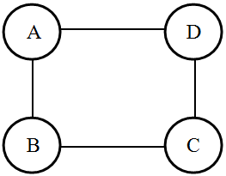

Here, this graph consists of four vertices and four undirected edges. Since all the edges are undirected, therefore it is a non-directed graph.

4. Directed Graph:
Definition: A graph in which all the edges are directed is called as a directed graph. In other words, all the edges of a directed graph contain some direction. Directed graphs are also called as digraphs
Example:
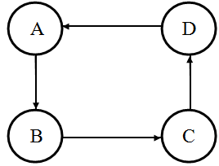
Here, this graph consists of four vertices and four directed edges. Since all the edges are directed, therefore it is a directed graph.

Continue

